**Matterport report**

**Balance sheet**

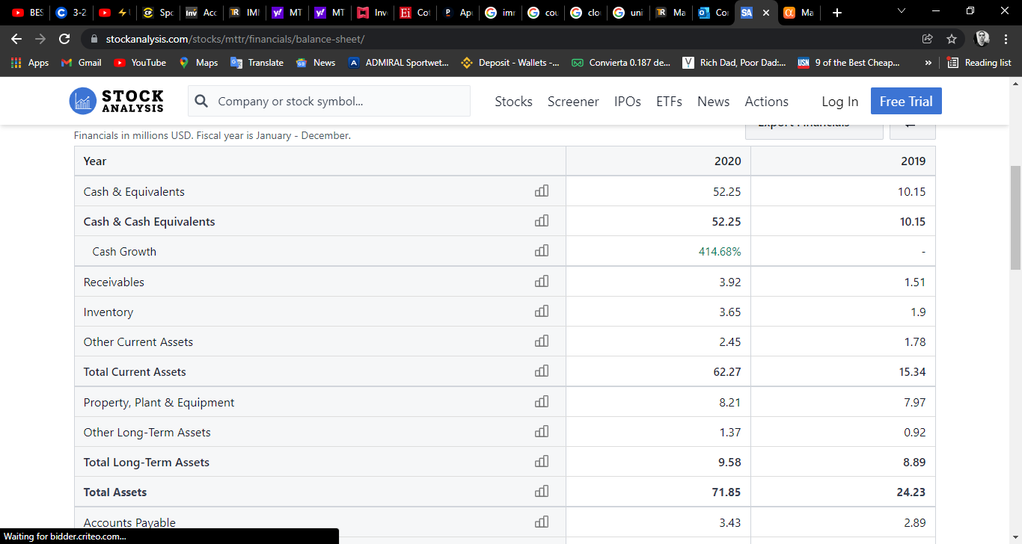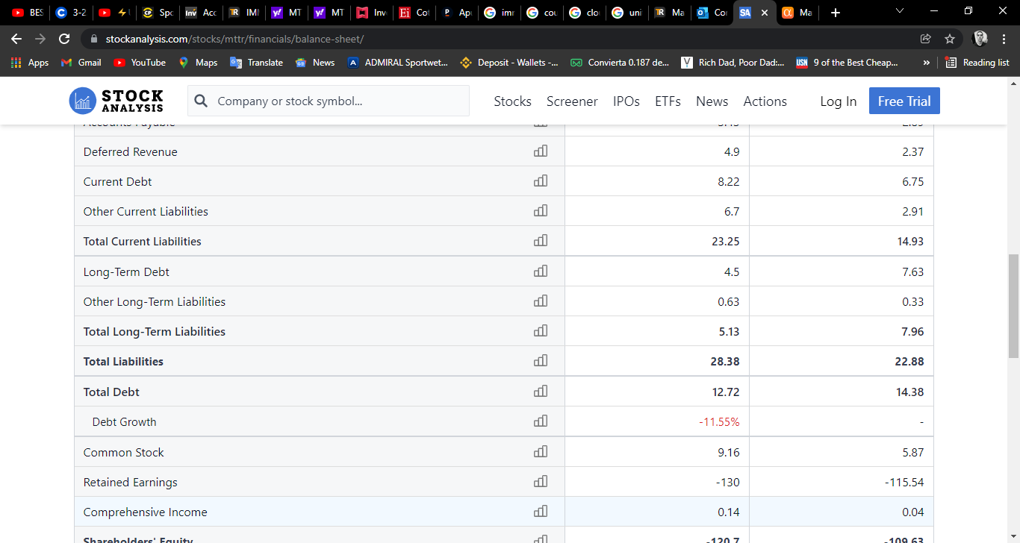

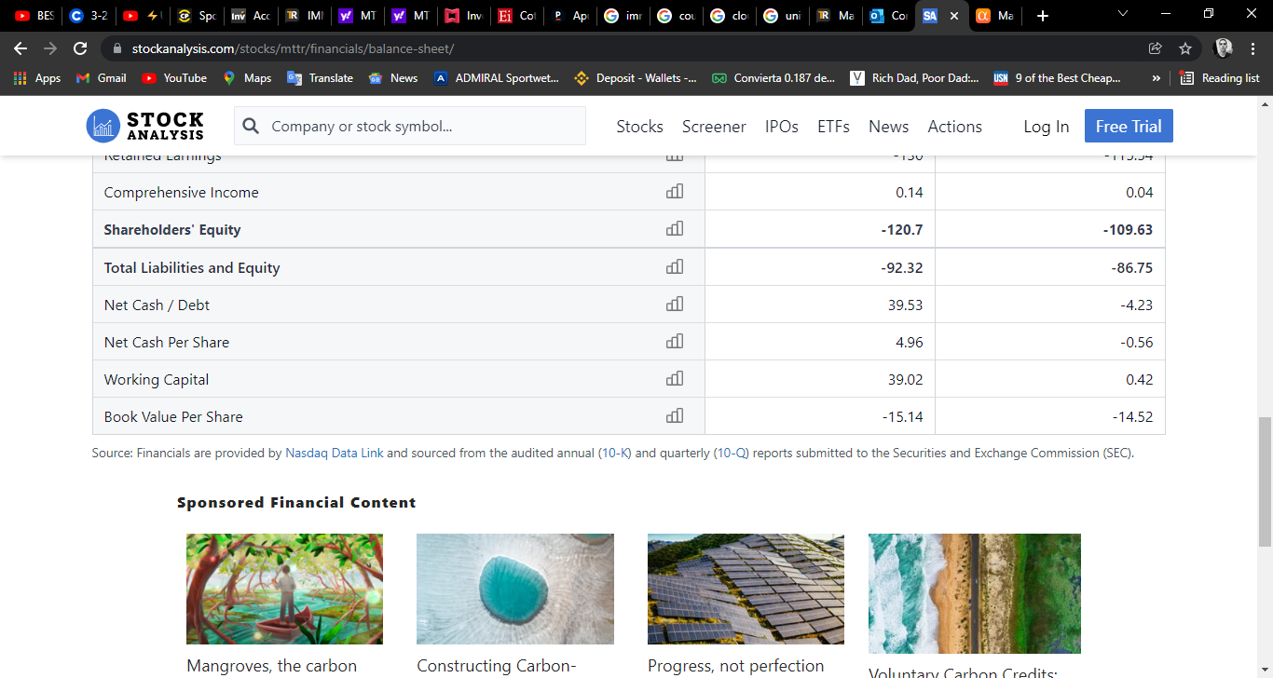

**Cash flow**

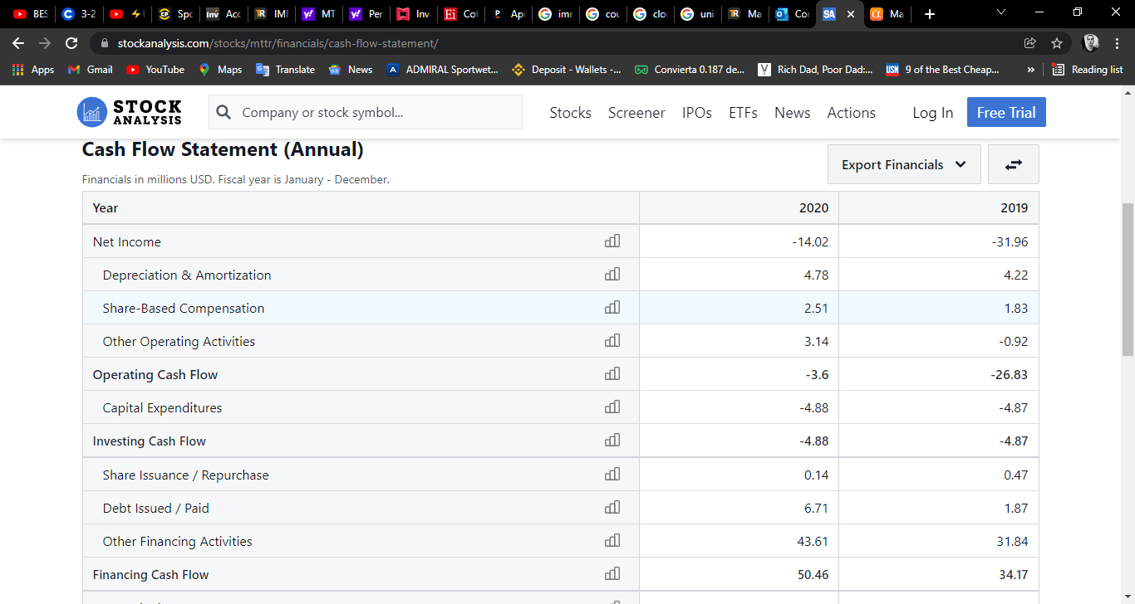

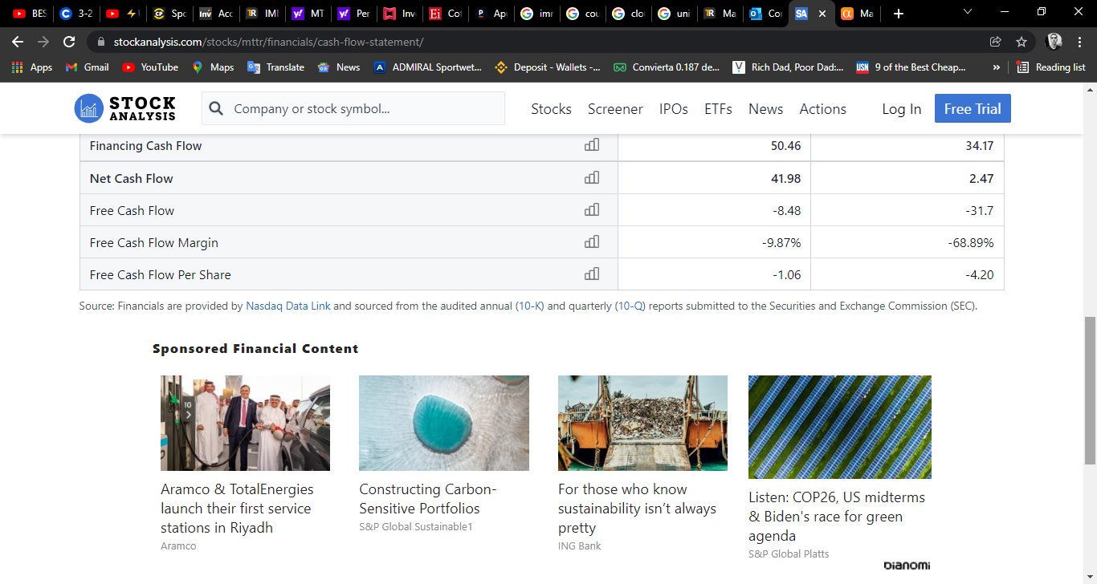

**Fundamental ratio**

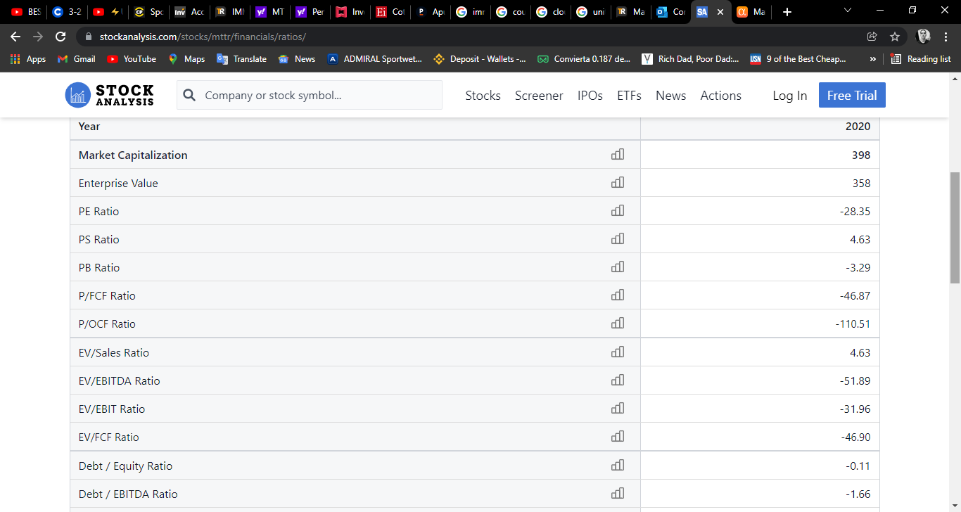

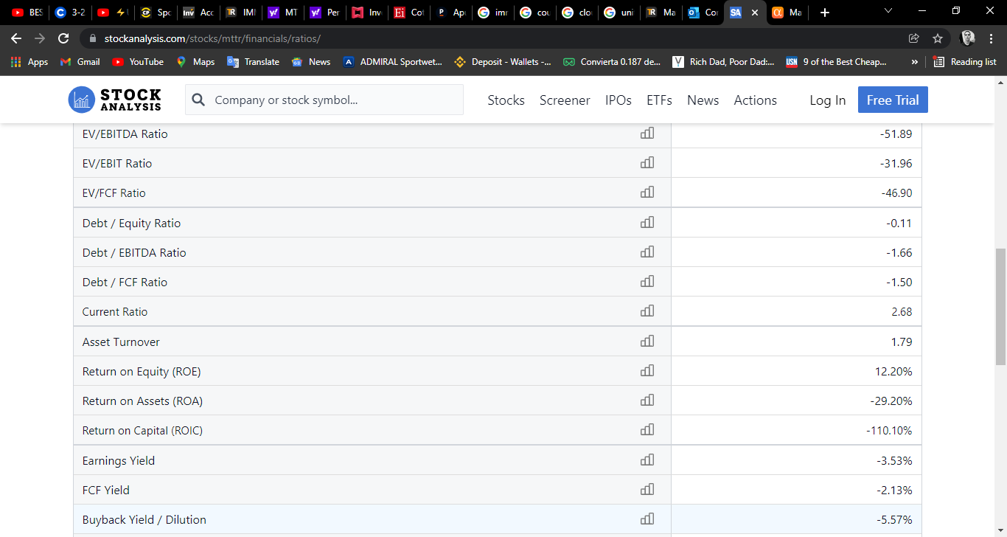

**Analisys matterport**

* Matterport is a fast-growing company leading the digital transformation of the built world.
* It holds a first-mover advantage and several key barriers to entry in a large and virtually untouched market.
* Strong gross margins and an increasing focus on its highly scalable subscription business should contribute to future profitability.
* Due to the volatility of the stock and expensive valuation, I recommend initiating a long-term position and continuing to purchase shares on any weakness.

**Investment Thesis**

Matterport (NASDAQ:[MTTR](https://seekingalpha.com/symbol/MTTR?source=content_type%3Areact%7Csection%3Amain_content%7Cbutton%3Abody_link)) dominates the large and growing market for 3D digital replicas of buildings. A growing subscription business, impressive profitability potential and a massive addressable market position the company well to continue its strong performance. I recommend investors purchase shares with a long-term (5+ years) view and continue to add to their position on any price weakness.

**Company Overview**

Founded in 2011, Matterport operates a technology platform that creates digital 3D models of buildings using a collection of data points unique to each reconstructed space. These models and the associated data benefit customers in a variety of ways, including:

* real estate brokerages can offer virtual open houses;
* retailers can manage thousands of store locations remotely;
* construction firms can improve the efficiency and accuracy of their monitoring processes; and
* insurance firms can improve the documentation and evaluation of claims and underwriting assessments.

Matterport generates revenue through [four business segments](https://investors.matterport.com/node/7496/html):

* Subscription (~52% of Q2 2021 revenue): freemium model that offers subscription plans varying from single user / single space to multiple users / unlimited spaces with price points dependent on the number of users and active spaces.
  + *Management has voiced the expectation that more than 80% of revenue will be subscription-based by 2025. I will further explain the benefits of the focus on its scalable subscription model a bit later.*
* Product (~39%): sales of the Pro2 Camera.
* Services (~10%): on-demand capture services provided by Matterport for enterprise subscribers worldwide; also includes in-app purchases such as schematic floor plans made on Matterport's iPhone or Android apps.
* License (~7%): data license solutions that allow customers access to the company's proprietary digital twin data; license revenue is highly variable as the licenses are perpetual, and the company books revenue upon delivery of the licensed data.

**First Mover Advantage In Large, Untapped Market**

Matterport maintains a significant first mover advantage and dominates the large and unpenetrated digital reconstruction market. With 5.6 million spaces under management (digitized building scans), the company is estimated to have 100x the amount of spaces on its platform as the entire rest of the nascent market. This unrivaled scale enables it to provide customers with spatial data insights from its vast library of three billion 3D data points. Most importantly, a fully automated digitization process enables the company to scale effectively as more of the built world comes online. This highly scalable technology platform differentiates Matterport from other fast-growing companies such as Zillow (NASDAQ:[Z](https://seekingalpha.com/symbol/Z?source=content_type%3Areact%7Csection%3Amain_content%7Cbutton%3Abody_link)), who are suffering from an [inability to meet the growth in demand](https://seekingalpha.com/news/3753456-zillows-home-flipping-service-pauses-to-work-through-backlog-bloomberg?source=content_type%3Areact%7Csection%3Amain_content%7Cbutton%3Abody_link).

Management estimates the total addressable market for 3D reconstruction to be more than 20 billion spaces across the world. Within this, it estimates the current serviceable addressable market to be 1.3 billion spaces worldwide, meaning Matterport has penetrated the market by less than 1%. With an established presence in the marketplace and a customer list including 13% of the Fortune 1000, the company has immense potential and a long runway for growth. For Q2 2021, Matterport increased its spaces under management by 75% as it continues to leverage its leadership position to further penetrate the market.

**Subscription Growth & Customer Wallet Share Expansion**

Matterport's subscription platform has exhibited tremendous growth over the past two years as the company has shifted its focus from product-based sales to a subscription-based business. Operating a freemium model, Matterport is in the early stages of customer acquisition, only recently having rolled out its Matterport Capture app for iPhone (May 2020) and Android (May 2021). These launches have contributed to a 29x increase in subscribers from FY 2018 to Q2 2021.

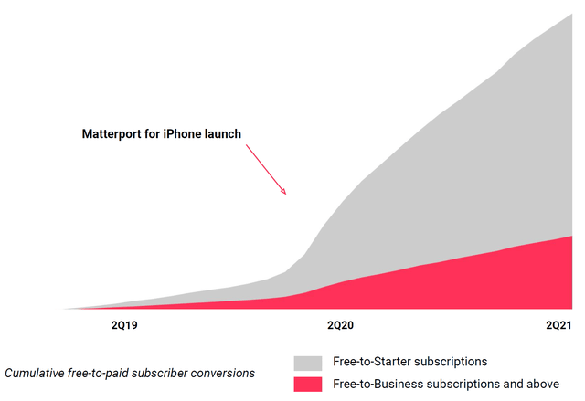

As the momentum from the freemium model gains further traction, the company should continue to exhibit consistent growth. The company had 353k free subscribers (~187% growth YoY) and ~51k paid subscribers (~53% growth YoY) as of Q2 2021. As customers continue to be drawn in with free subscriptions, they will transition into paid subscribers (typically within 30-45 days after downloading app, per [Q2 conference call](https://investors.matterport.com/static-files/106ba450-56cc-4e6a-99ab-d6f64fa99081)) as they recognize the value and cost-saving potential of Matterport's 3D data.

Cushman & Wakefield, one of the largest commercial real estate services firms in the world, is one example of an enterprise customer who has recognized hard dollar cost savings from implementing Matterport's 3D capture within its operations. From 2018 to 2020, Cushman & Wakefield increased their spend with Matterport by over 26x. Additionally, Ericsson, one of the largest cable operators in the U.S., increased their spend with the company by 60% from 2019 to 2020 as it can now manage thousands of cable structures remotely. Overall, customers have demonstrated continuously increasing spend with Matterport as evidenced by sequential record net dollar expansion rates of 112%, 129% and 132% for Q4 2020, Q1 2021 and Q2 2021, respectively

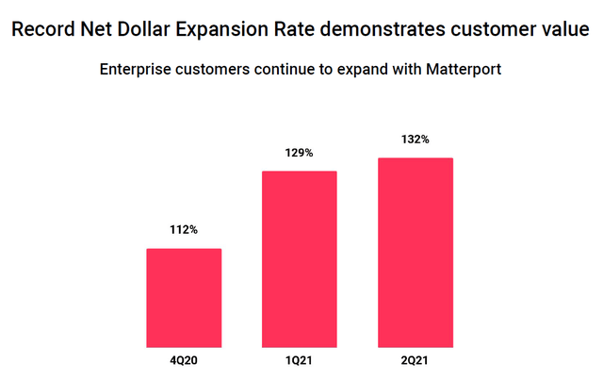

Source: Q2 2021 Earnings Slides

The tangible value provided by Matterport will continue to drive wallet share expansion with existing customers while also growing the subscriber base through a proven freemium model. This growth of the subscription business will contribute substantially to the future profitability of the company as it operates at a 70%+ gross margin.

## Financial Performance Analysis

Having only been a public company ([via SPAC in July 2021](https://www.bloomberg.com/news/articles/2021-02-08/matterport-to-go-public-via-gores-spac-in-2-9-billion-deal)) for around three months, there is not a great deal of long-term financial data out, but the data that is available contributes to the company's merits.

For Q2 2021, Matterport reported $29.5 million of revenue, ~21% YoY growth, while subscription revenue increased ~53% YoY to $15.3 million. Although this top line growth does not blow investors away, it is notably more impressive in light of the fact that revenue in the comparison quarter, Q2 2020, grew ~117% YoY as the pandemic accelerated the digital transformation of real estate by several years. Q2 2021 revenue grew ~10% sequentially, demonstrating continued momentum of the business.

Strong growth in the subscription business (~53% YoY revenue growth in Q2 2021) has improved the company's profitability as well, demonstrated by gross margin expanding 740 basis points YoY to ~60% in Q2 2021. The subscription business operated at a ~78% gross margin during the quarter, indicating the potential for substantial profitability growth as the company continues to scale its subscriber base and transition away from product-based sales.

While Matterport is not yet GAAP profitable, having lost ~$14.0 million in FY 2020 and ~$6.2 million in Q2 2021, the loss is primarily attributable to investments in sales & marketing (~49% of FY 2020 revenue) and research & development (~21%) to sustain the current growth trajectory. More recently in the first half of 2021, sales & marketing has increased to ~52% of revenue and research & development has increased to ~23% of revenue.

While these increases in spending have thus far outpaced revenue growth, I believe this trend will reverse as the company realizes the benefit of more accessible, efficient customer acquisition methods (such as the late-quarter rollout of Matterport for Android). Per the Q2 conference call, the Android app will drastically expand the freemium funnel to over 5-6x the current number as it is the dominant global smartphone operating system ([over 80% of the market](https://www.idc.com/promo/smartphone-market-share)).

An interesting anecdote mentioned by management on the call is that the company signed up more subscribers in the first three days of deploying Matterport for iPhone than it had in the first eight years combined. With Android reaching significantly more users worldwide, it is fair to expect a repeat of the impressive subscriber growth as the app continues to penetrate the leading operating system. Total subscribers increased 158% YoY in Q2 2021, and I see no reason for this rapid growth to slow moving forward.

## Liquidity & Balance Sheet Analysis

Pro forma for the now-consummated SPAC business combination, Matterport maintains a rock-solid balance sheet with ~$637 million of cash, ~$627 million of working capital and zero debt as of Q2 2021.

Despite not producing positive cash flow yet, the strong cash and working capital balances provide a base for stable operations with continued investment in the business. For FY 2020, the company used ~$3.6 million of cash in operating activities and ~$4.9 million in investing activities. Even assuming a hefty increase in annual cash burn while the company continues to invest in growth, the company maintains ample liquidity with the balance sheet posing minimal concerns for investors.

## Valuation & Considerations

There is no denial that Matterport is a richly valued company at a market cap of approximately $4.9 billion. Revenue for the trailing-twelve months ending Q2 2021 was $105.1 million, resulting in a nearly 47x price to sales multiple. Such an expensive valuation certainly decreases the margin of safety for any investment, yet I do not believe it impairs the multi-year investment thesis for investors willing to hold through years of a volatile stock price.

Despite $4.9 billion seeming like an impractical valuation, I believe the company's dominance of the digital reconstruction market coupled with a total addressable market in excess of $240 billion mitigates this risk through a long and easily scalable runway for growth. The spatial data insights gained from digital 3D models are nearly universally applicable across industries, including real estate, retail, insurance, government and architecture, engineering & construction. As Matterport continues to draw subscribers into its freemium funnel, it will scale alongside the customer base's growing demand for spatial data.

Beyond the valuation, Matterport operates in the vast, unpenetrated digital reconstruction market and as such, faces a significant risk from new, innovative market entrants. However, Matterport's first mover advantage coupled with several key barriers to entry help to insulate the company from new competitors attempting to steal market share. For one, Matterport has been focused on this growing industry for ten years, spending that time developing its best-in-class technology platform, which provides a significant head start against any competing technology. Additionally, the company's growing database of three billion 3D data points unlocks customer insights that perpetuate the company's leading market position. Finally, as mentioned before, Matterport continues to protect its market leadership through investment in research & development and a portfolio of 38 issued and 28 pending patents. Taken together, these defensible qualities should protect Matterport from future entrants.

Investors should be sure to consider - similar to any small, fast-growing company - that Matterport will continue to be unprofitable for the foreseeable future as it invests heavily in developing its technology, acquiring subscribers and securing its leadership position in the market. It is for exactly those reasons, however, that I do not consider this risk to alter the investment thesis. In order to defend its market position and maintain its strong track record of growth, the company must continue its business re-investment. Upon achieving a critical mass, the company can then leverage its high gross margins to scale revenue without proportionate increases in sales & marketing and research & development expenses.

Lastly, the volatility of the stock price poses a meaningful risk to investors who may panic and sell at a time when pessimism prevails in the market.

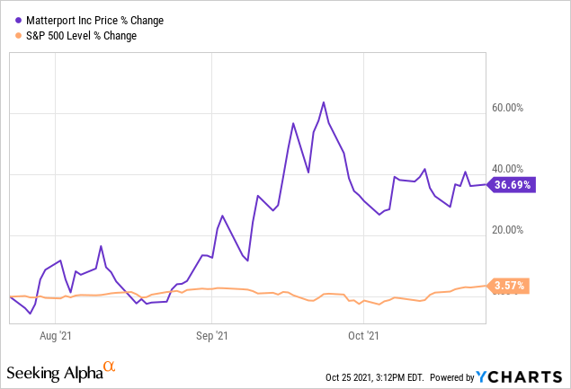

## Conclusion

I believe Matterport's entrenched market position, fast-growing subscription business and strong prospects for profitability will propel the company to future success. Investors who are willing to withstand a volatile stock price while the company emphasizes expansion over profitability should initiate a position in the company, continue to monitor its performance and purchase additional shares on any weakness moving forward (so long as the company continues to perform). In closing, I will leave a quote from the CEO, Roger Pittman, which outlines the essentiality of a long-term view (I recommend 5+ years minimum) when investing in Matterport:

Matterport is a unique business leading the digital transformation of an entire industry. We believe the growth opportunity ahead will be measured in years and decades, to be captured through our proprietary technology, thoughtful execution, and bold leadership. Quarter to quarter, we expect the market to be very dynamic as the industry evolves and the transformation takes hold.

**Advantage**

The Matterport system allows for **measurements at 99% accuracy**, the ability to walk someone through a home without being physically present in the home, the ability to share with carriers and homeowners to improve communication, and greater process and business efficiencies

**Disadvantages**

**The main disadvantages of the Matterport platform are:**

* Only certain cameras and scanners work with it, they try to push you to buy their proprietary Matterport Pro 2 3D camera.

For the price that it costs, the Matterport Pro 2 3D camera is subpar when compared to other competitors

**Market size**

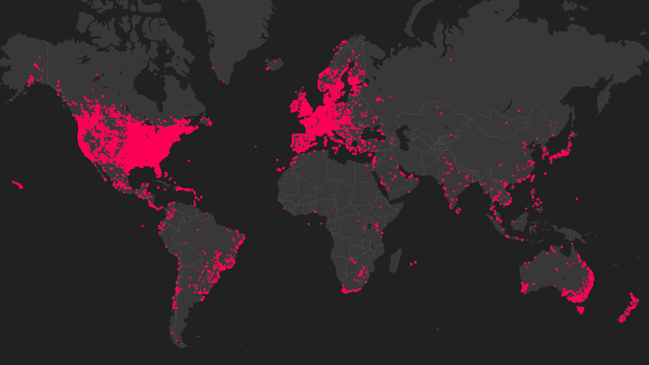

Global expansion

Headquartered in Sunnyvale, Calif., Matterport has offices in San Francisco, Chicago, Kansas, London, and Singapore, enabling local sales and support.

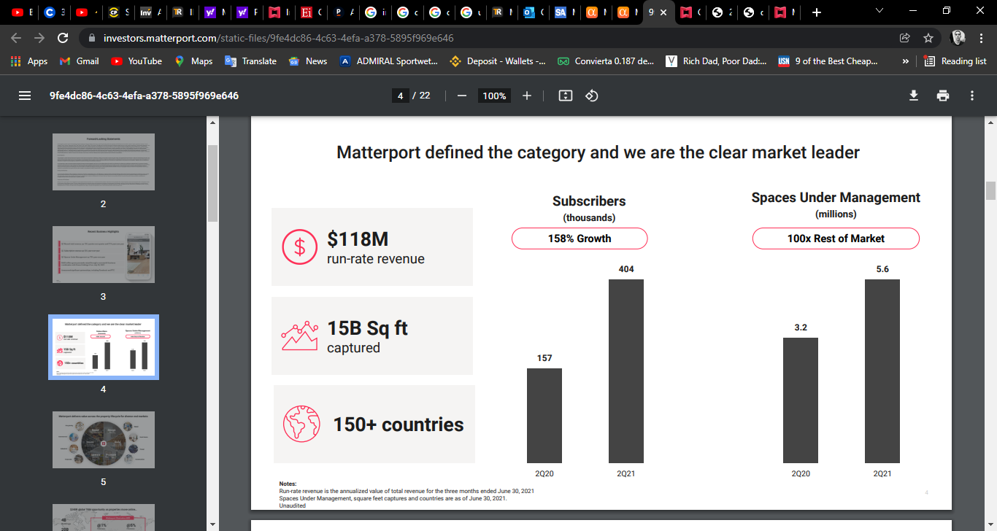

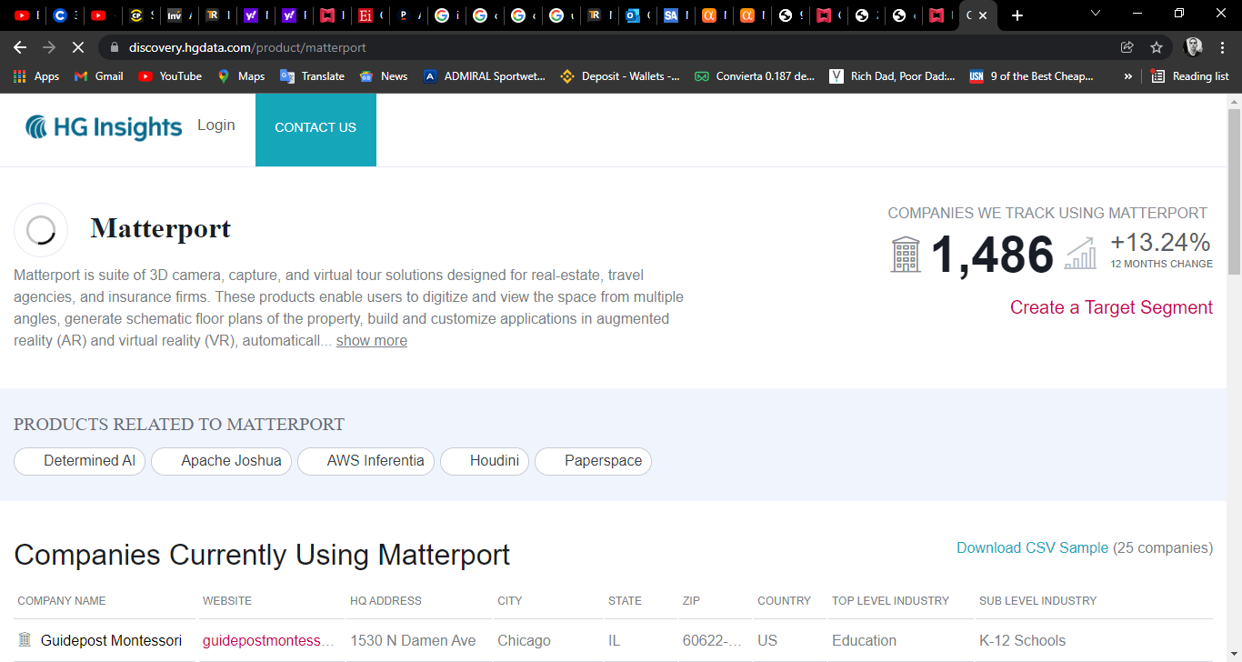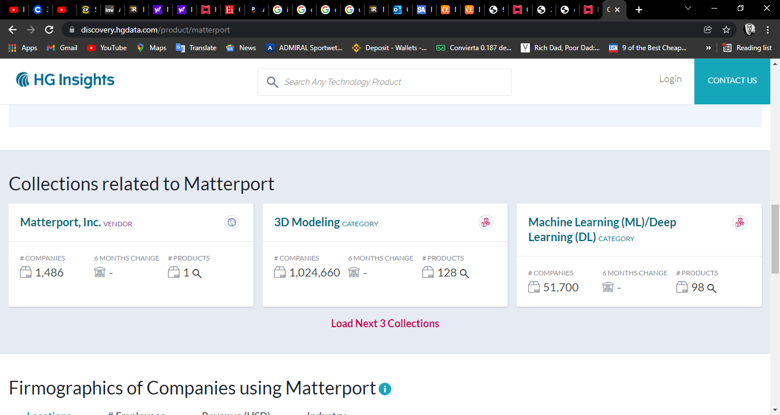

**diversification**

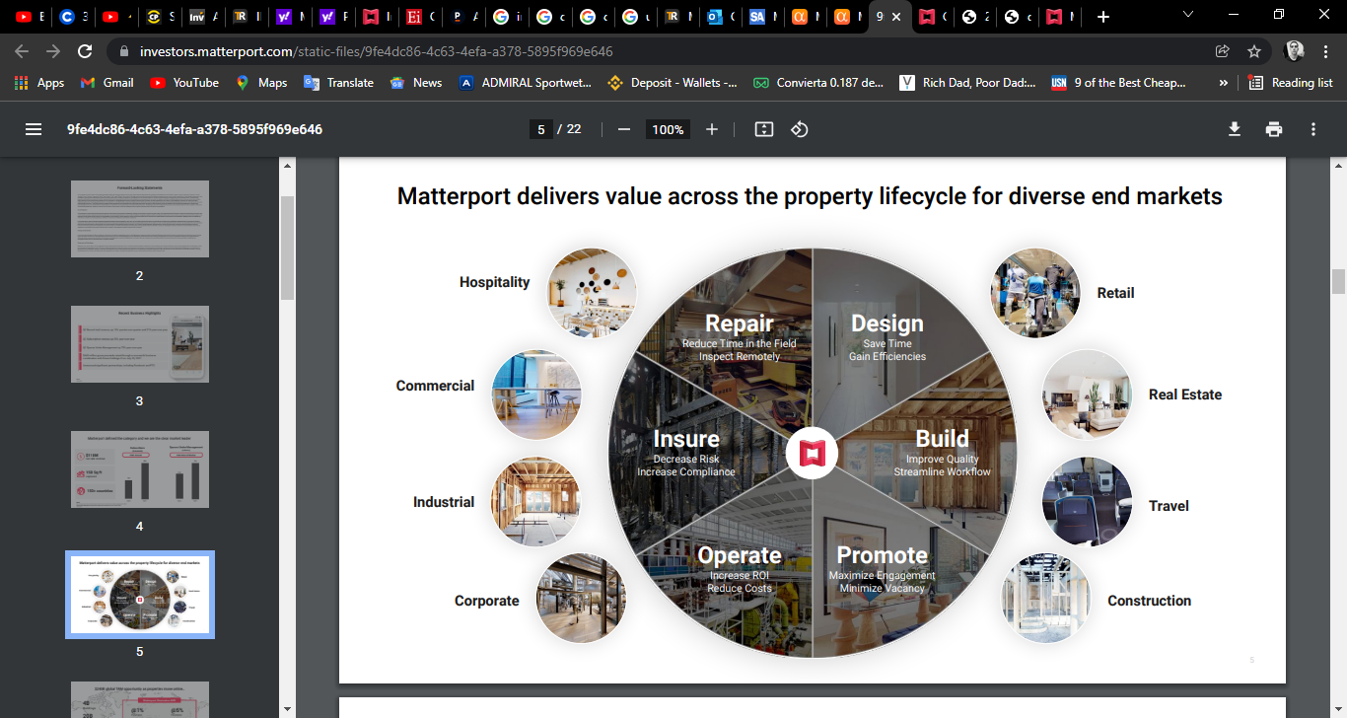

.

**Analyst advice**

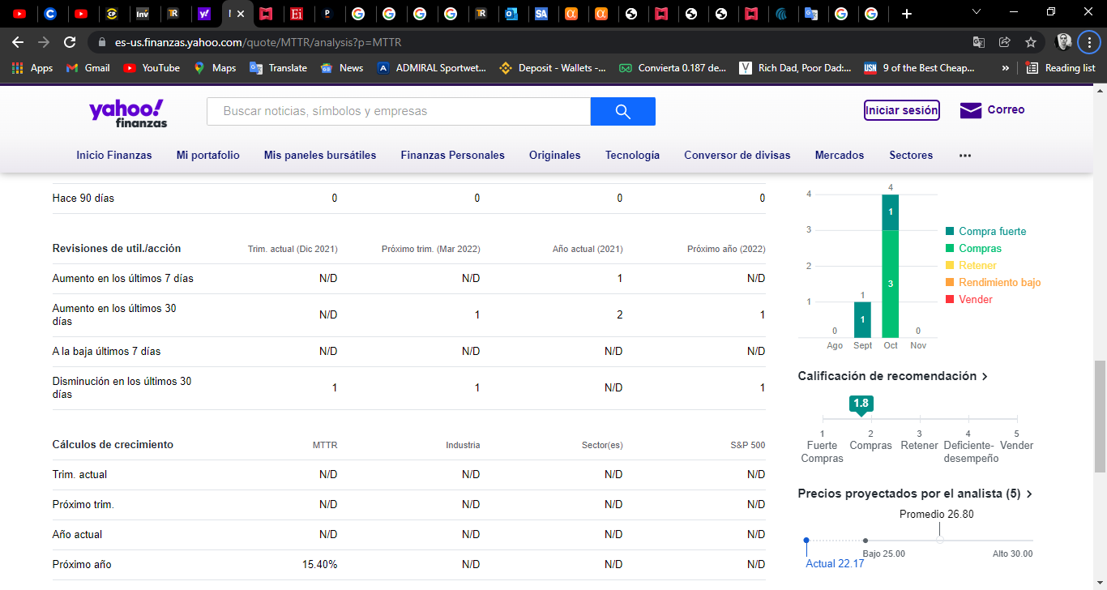

**Stock matterport**

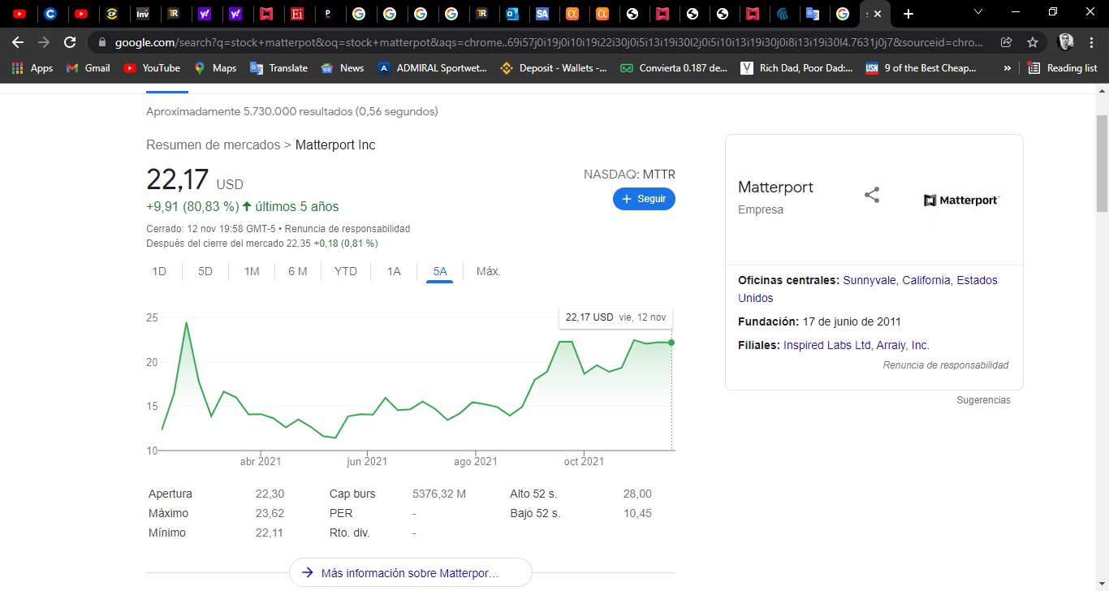

**Stock analyst**

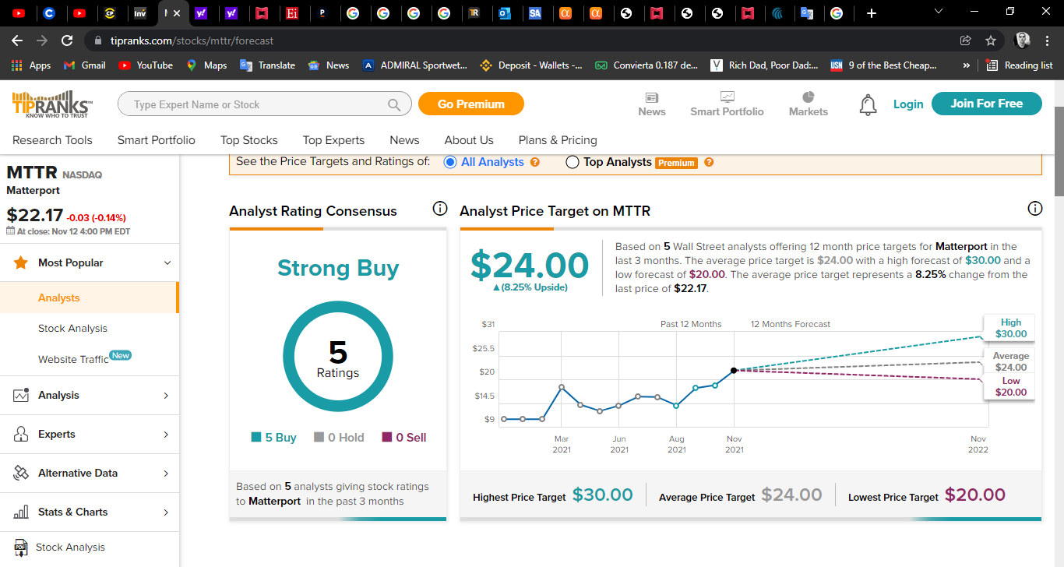

**From Tipranks we see that the average advice is to buy for 5 of the 5 analysts who follow the value on the NYSE, Its target price is $ 24.00 per share, so its route is limited. Its potential in particular reaches 8.25%**

**Growth matterport**

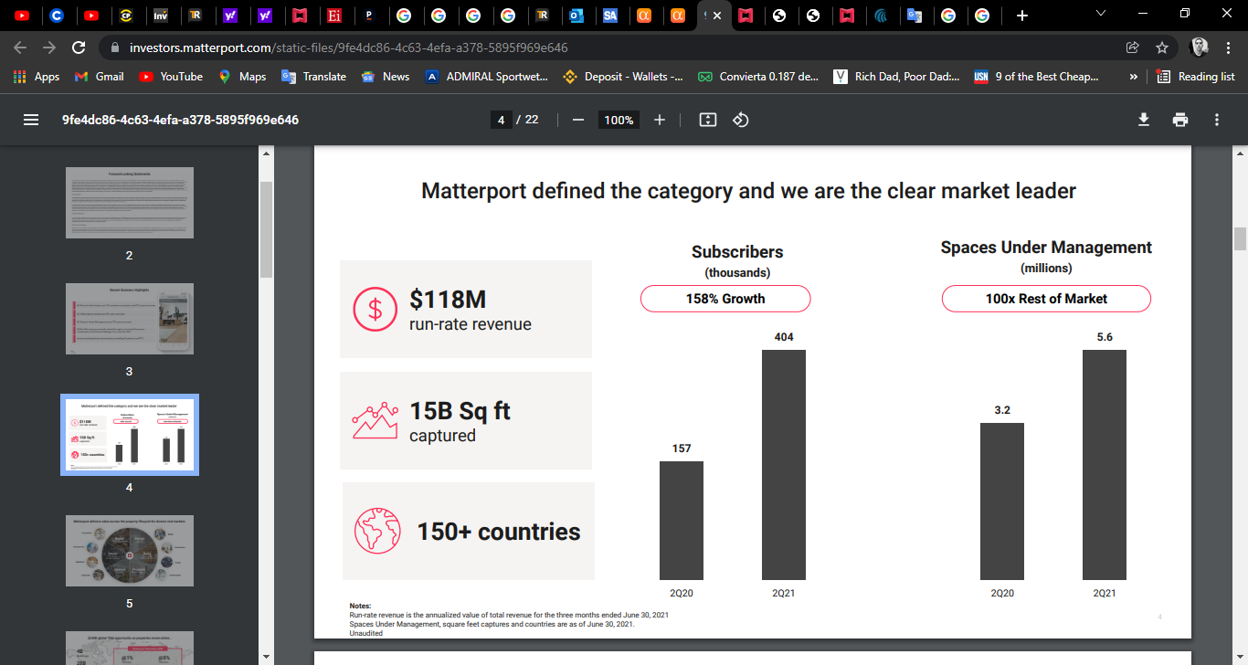

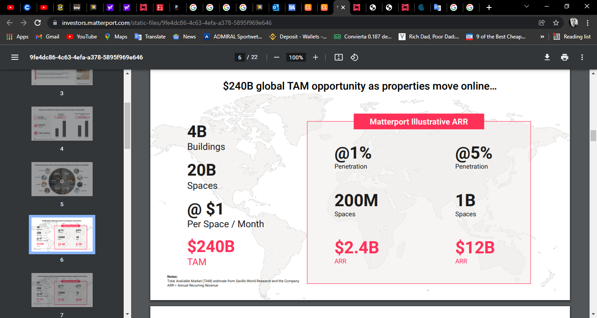

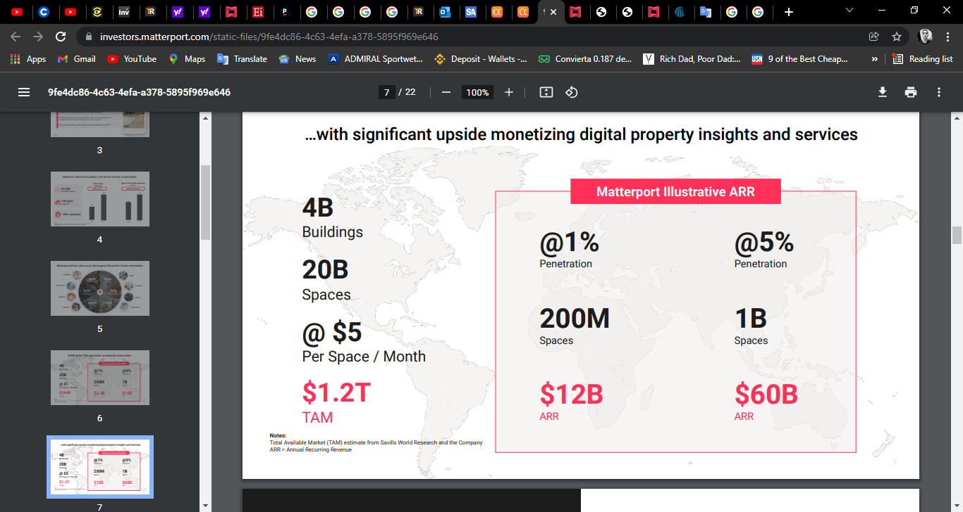

**Products**

Matterport, Inc., a spatial data company, focuses on digitizing and indexing the built world. It offers Matterport digital twins, a 3D data platform to design, build, operate, promote, and understand spaces. The company offers Matterport Capture, an application that enables to capture depth, data, and imagery of a space using 3D cameras, 360 cameras, and iPhones; Matterport Workshop application to customize, add additional details, and share spaces; Matterport Showcase application for audience view and explore space in its final format; and Matterport VR to experience virtual reality. It offers solutions for real estate, photography, travel and hospitality, retail, insurance and restoration, industrial and facilities management, architecture, and engineering and construction industries. Matterport, Inc.

**Risk**

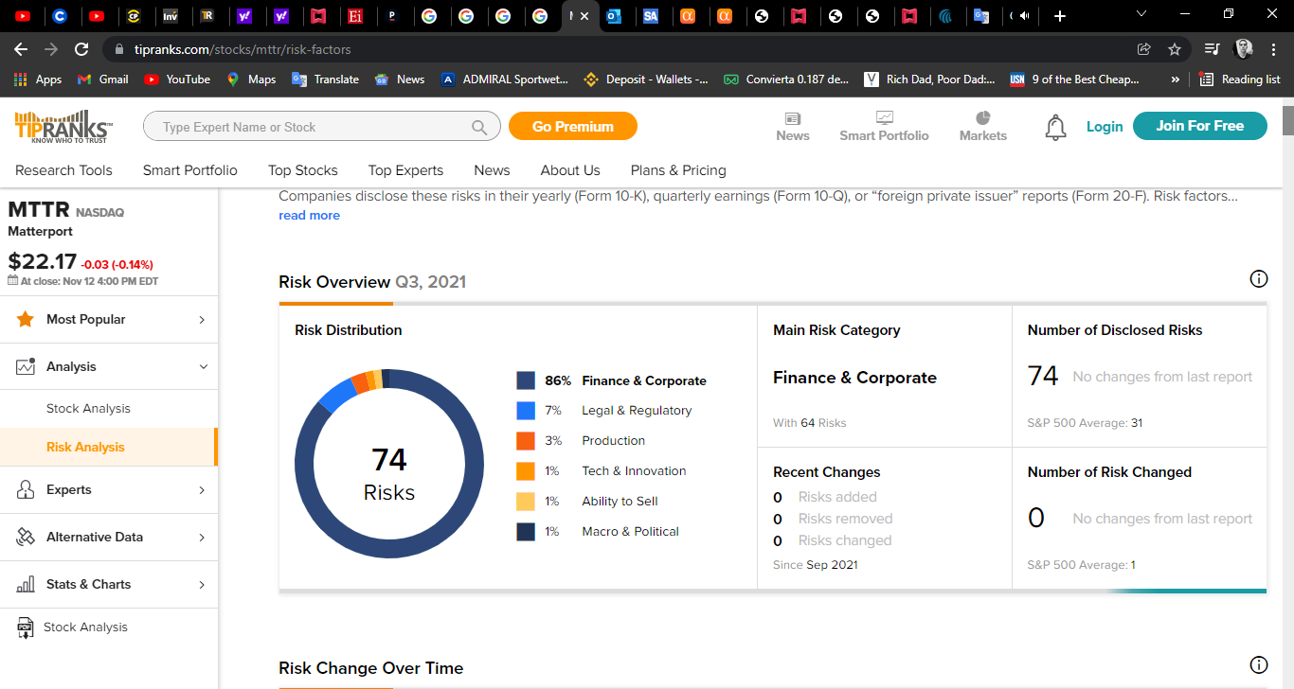

**86%Finance & Corporate**

7%Legal & Regulatory

3%Production

1%Tech & Innovation

1%Ability to Sell

1%Macro & Political

**Lean canvas**

